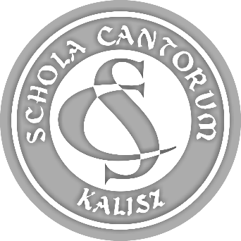 | PARTICIPATION FORM  44th SCHOLA CANTORUM  Tadeusz Krokos  International  Festival of Early Music Ensembles  Kalisz 2022

ATTACHMENT 7.

CONSENT TO THE PROCESSING OF PERSONAL DATA
AND DISSEMINATION OF IMAGE

(every participant of the Festival signs the consent individually
and sends in the scanned document).

Name of ensemble:
First name and surname:

In connection with the participation in the 44th SCHOLA CANTORUM - International Festival
of Early Music Ensembles I give consent to unpaid and multiple recording and publicising of my personal data (such as first name, surname, place name without detailed address, delegating institution) and my image by the Organiser for information and promotional purposes through the Organiser’s website, social networking sites and in press/promotional publications and any other publications in topical articles concerning the Festival including media patrons of the event.

The present consent covers taking, recording, the storage and use of photographs and video films including sound without the obligation to approve them each time as well as their editing, copying and publicising through the Organiser’s website and publications in topical articles concerning the Festival.
The present consent may be withdrawn at all times, however, the withdrawal of the consent does not affect the legality of the processing carried out prior to its withdrawal.

Date: | …....... 2022
Signature
of instructor/conductor/leader
or adult participant:

Attention:
Obtaining the consent to the processing of personal data and the dissemination of image from the parents or legal guardians of nonadult participants, connected with the participation in 44th SCHOLA CANTORUM
- International Festival of Early Music Ensembles, is the responsibility of the instructor/conductor/leader
and should be submitted to the Organiser no later than on the date of the beginning of the Festival
in the direct formula or sent to the email address (section 9.1.a) in the online formula.

